**Backend – Spring Framework**

The complete code is managed in GIT repo with postman project.

https://github.com/arunbalajii/service_assignment.git

1. **User Service**

User Service controller is designed to let user to register their account and make transactions on it.

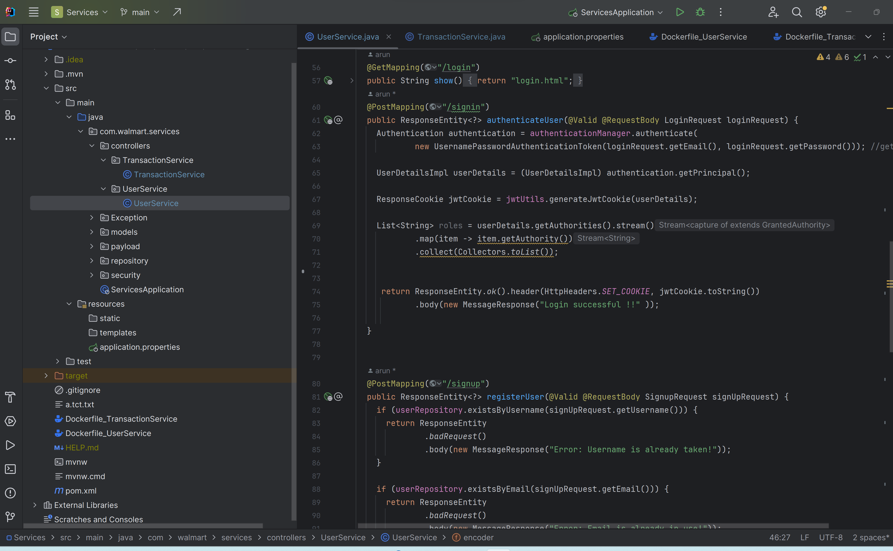

1. **User Registration:**

Creating new user for this process. It has 3 user checks for already existing username, email and phone num.

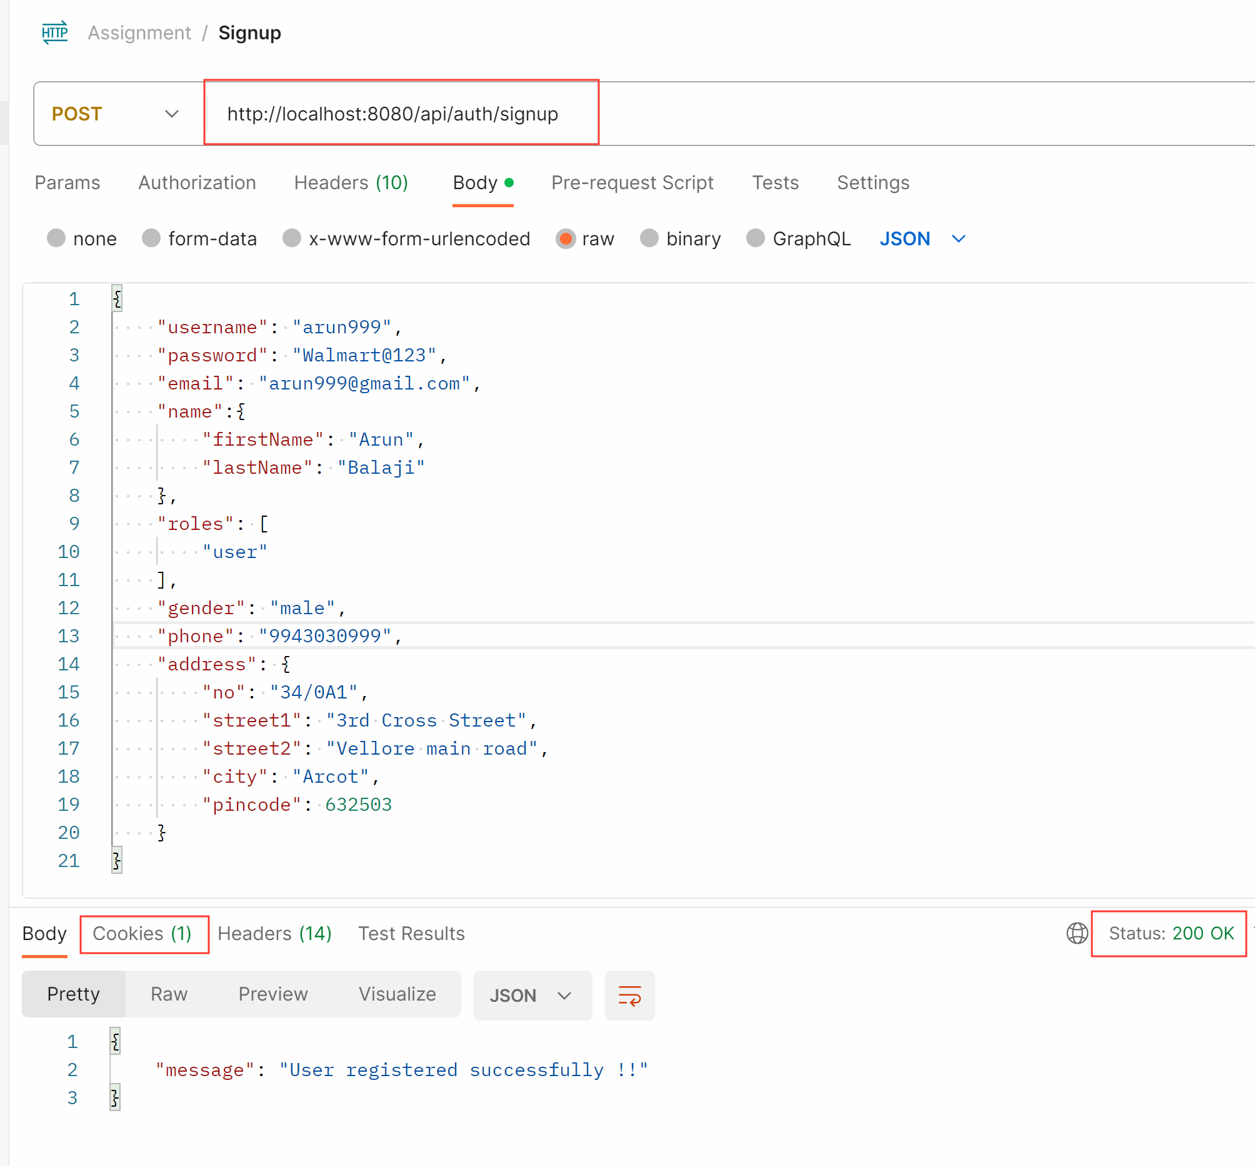

1. **User Registration (Existing User):**

If the user is already registered then it is prompted to register with new name likewise for email and phone number

1. **New User entry in DB:**

After registration the user details are captured and pushed to mongoDB. Initially the amount for that account is maintained as 0

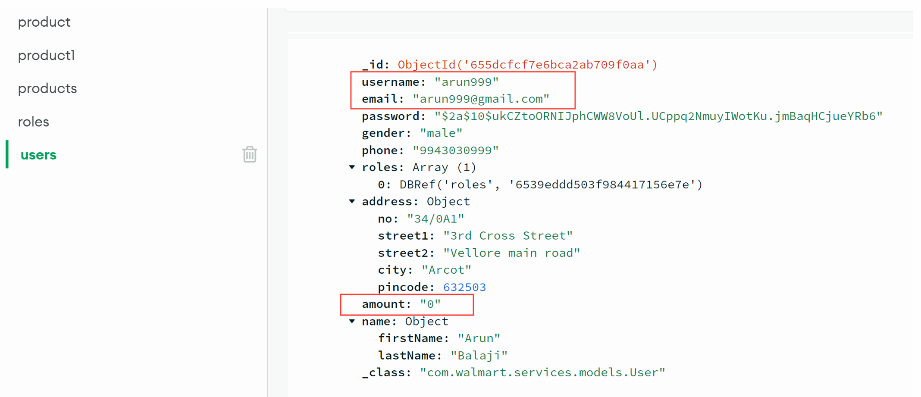

1. **User Login:**

Once user is registered they can able to login with their credentials. This will generate the JWT token saved as cookie will be helpful for further API calls.

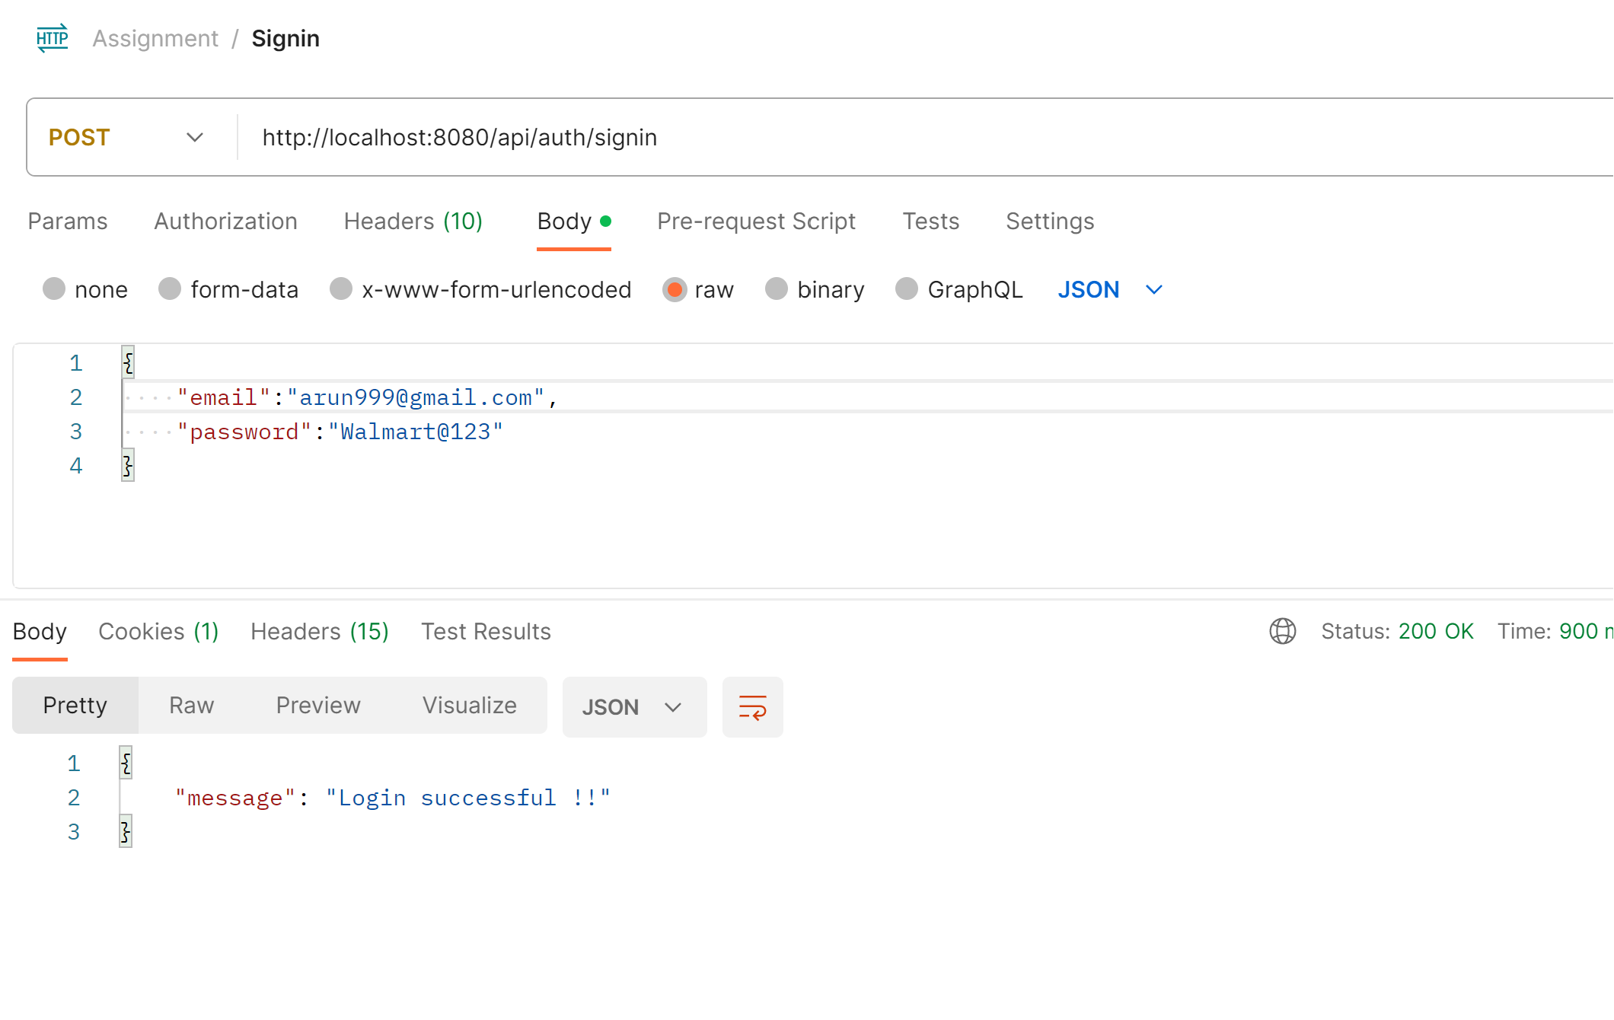

1. **JWT token generated for future API call validation:**

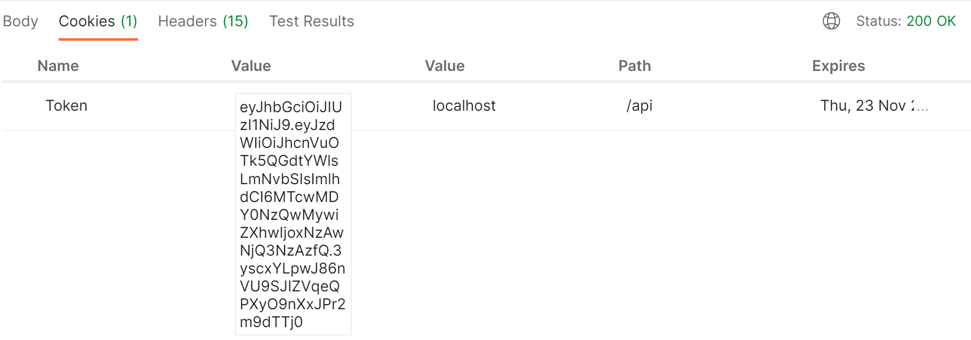

1. **User Login (Bad credentials):**

User with wrong credentials are denied access

1. **Transaction Service**

Another controller service which handles the transaction part for the user once after the token is validated

1. **Deposit to User account:**

For the deposit user no need to enter his account details in payload as it is captured and validated from the header token and deposit made to that account

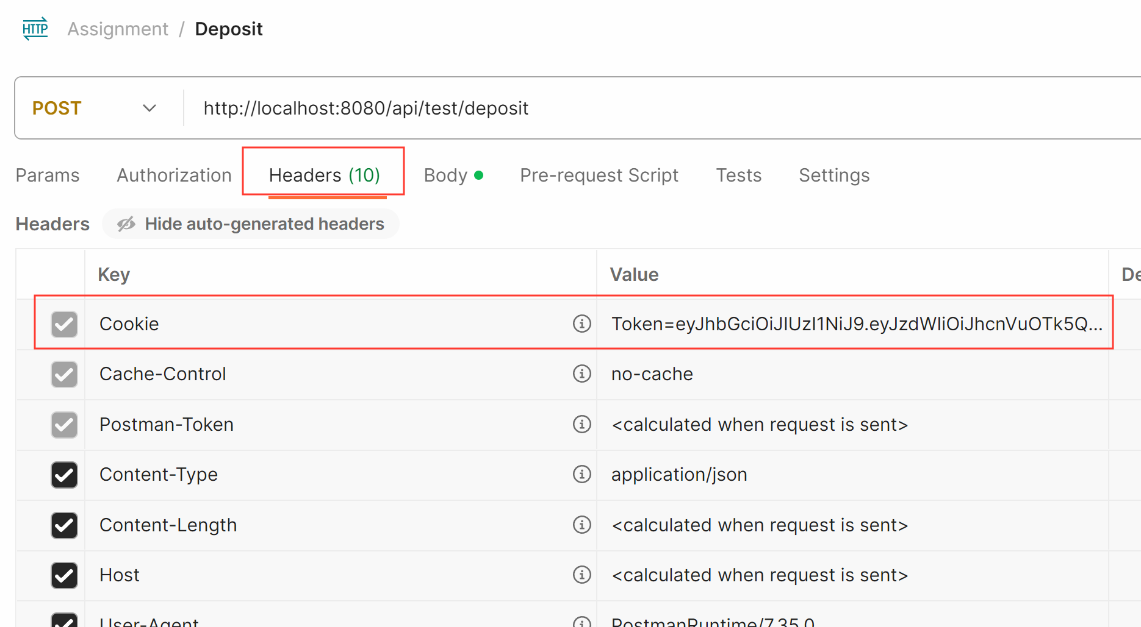

1. **Amount credited in DB:**

While the account creation the amount is 0 by default after deposit the DB is updated with his current value.

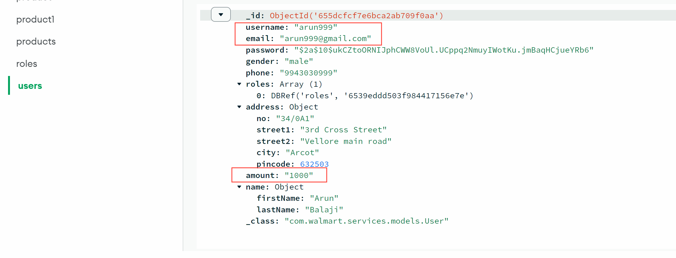

1. **If token is not present:**

Any user tries to do deposit directly backend will not know their account details hence they are advised to login with their credentials first. So that transaction could be made.

1. **Deposit (negative value):**

Another negative scenario to avoid impact on amount. Conditions are kept to check for the valid amount entered by the user in both deposit and withdraw

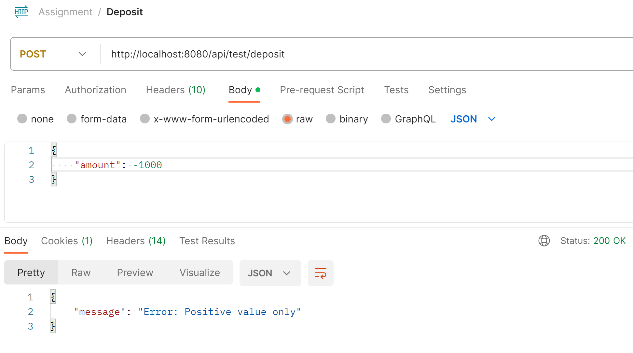

1. **Withdraw from the user account:**

Like deposit, withdraw is also designed with same set of conditions in validating token and avoiding the negative value. Once all condition met withdraw is allowed

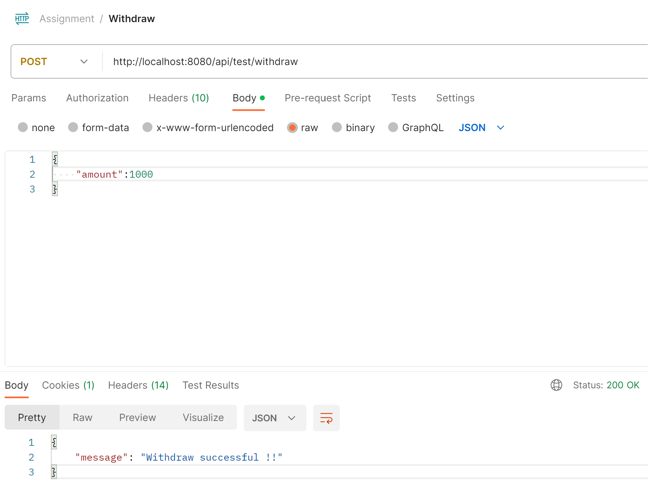

1. **Withdraw (negative amount):**

